Task-6 (Guided operations):

Workflow path -à C:/users/student/workspace/6_GO

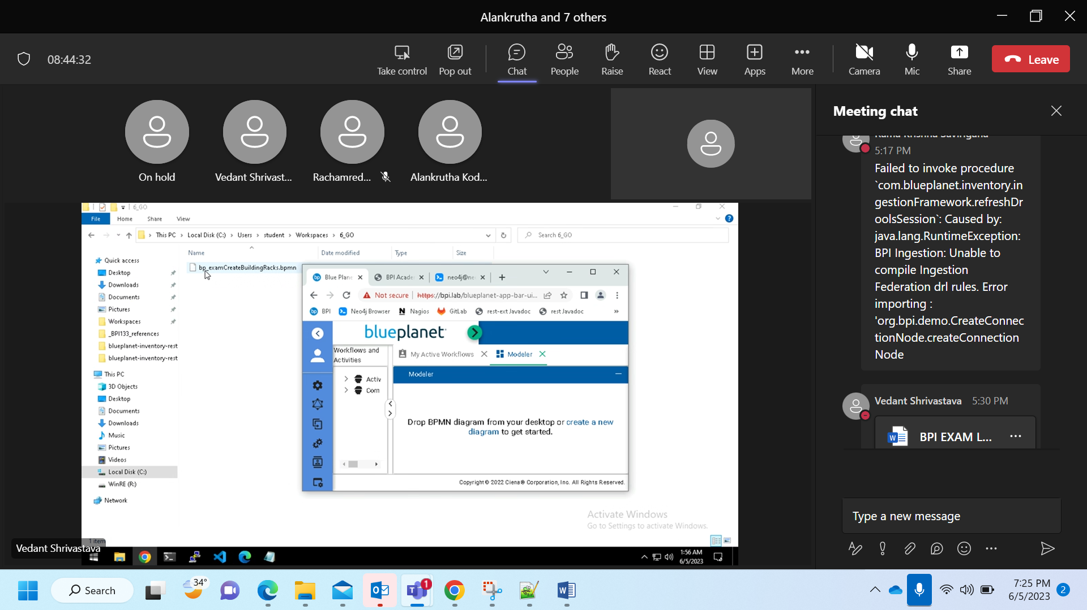

Drag and drop the workflow

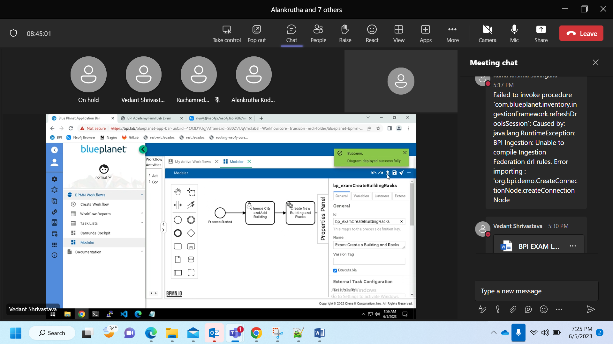

Deploy

Create new bpi server

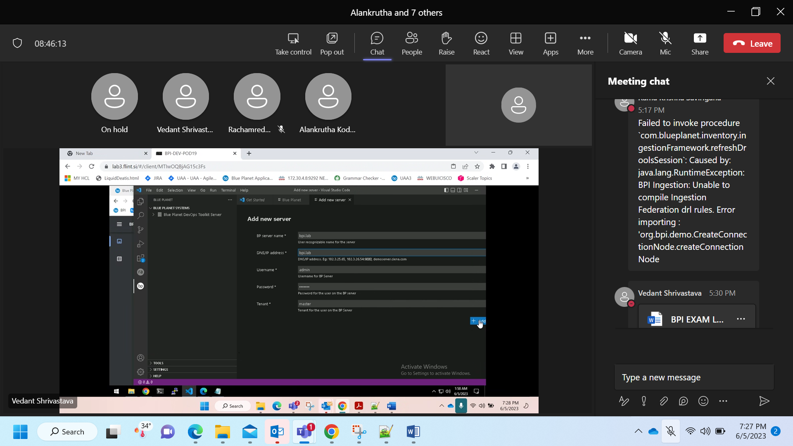

Push

Pull

clone

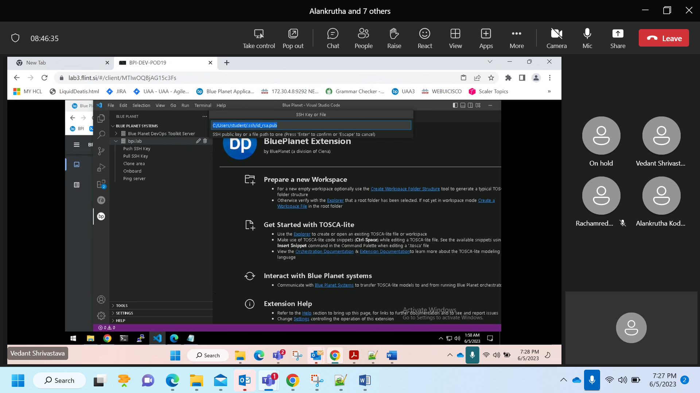

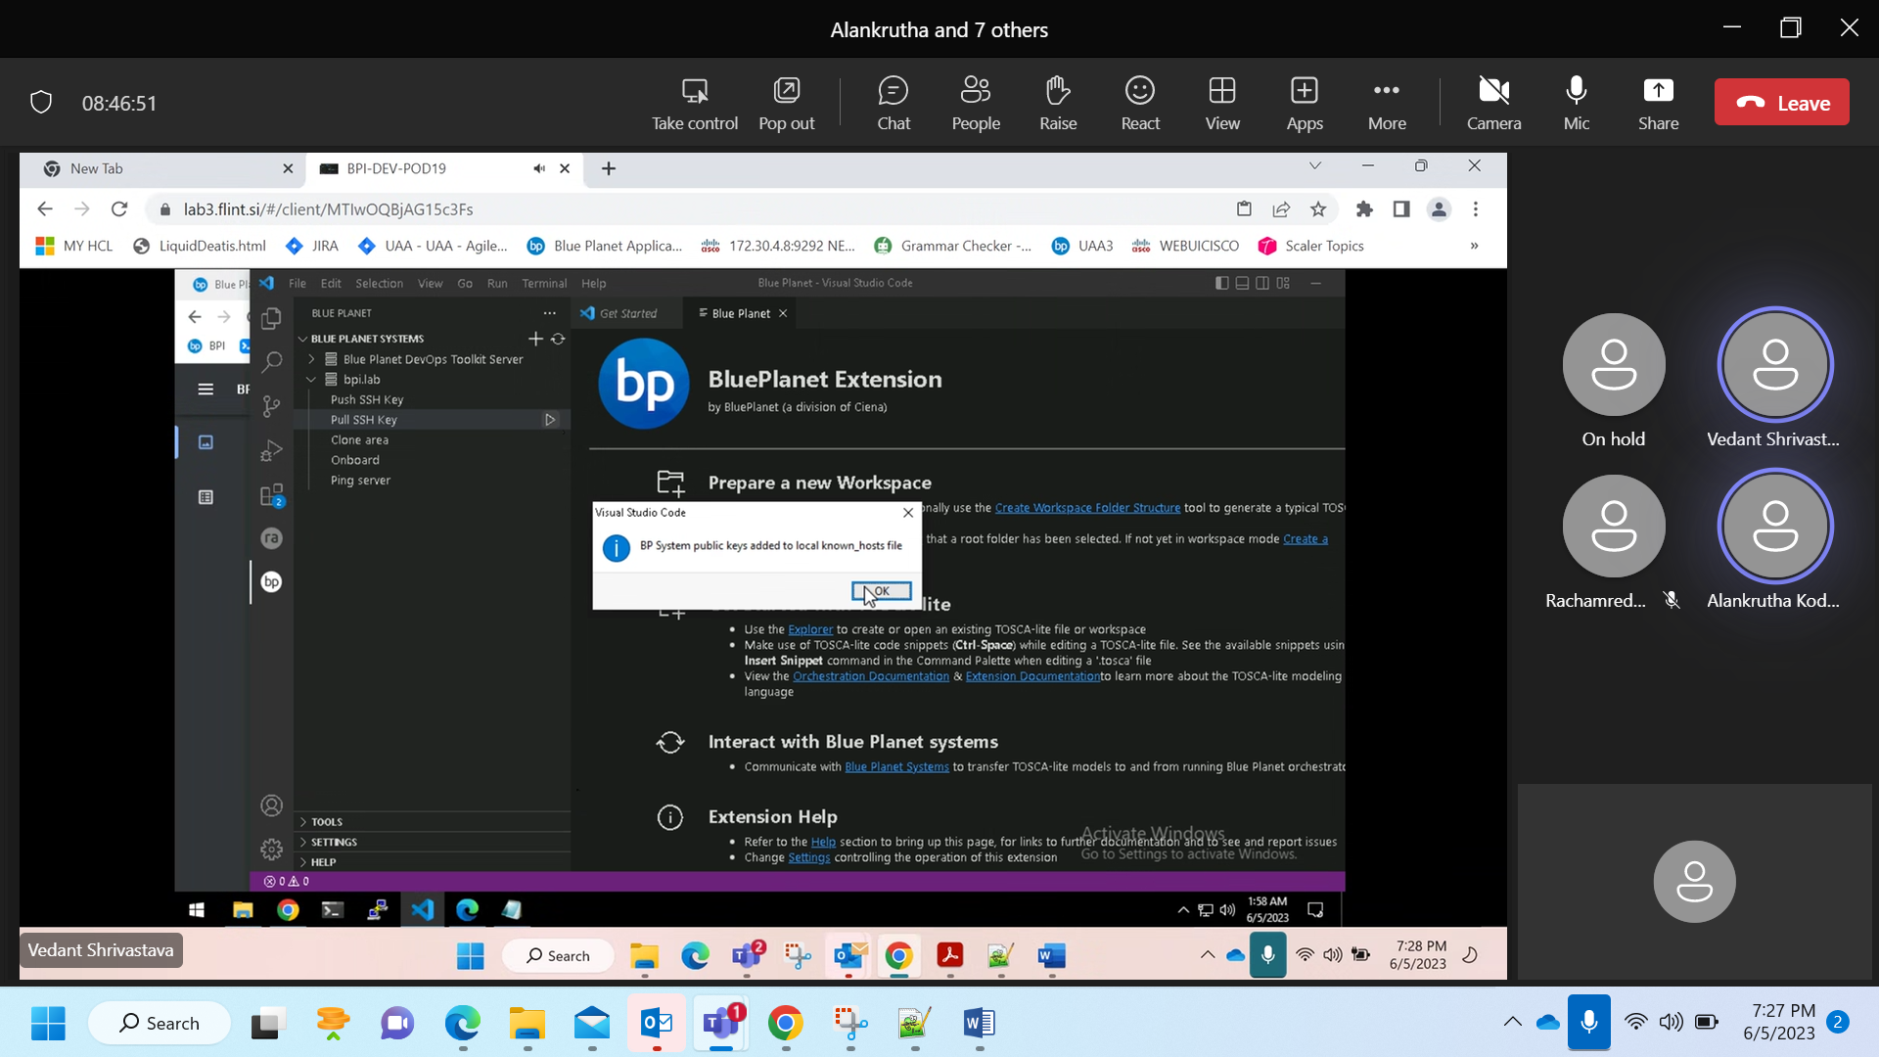

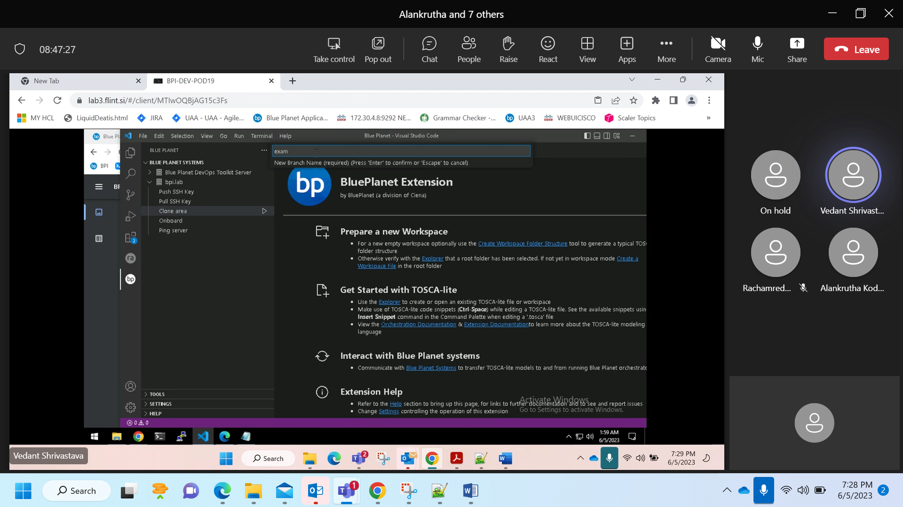

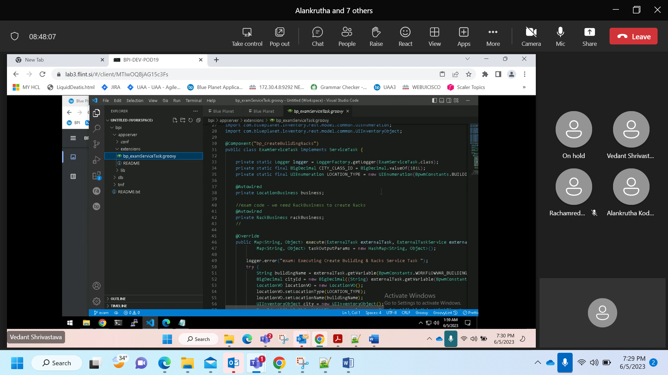

Update the groovy file name from **bp_examServiceTask.groovy** to **bp_createBuildingRacks.groovy**

Bean.xml:

Update the bean Id and the groovy file name.

<lang:groovy id="bp_createBuildingRacks" script-source="file:/bp2/tmp/sdk/extensions/bp_createBuildingRacks.groovy"></lang:groovy>

Code:

package bpi.appserver.extensions;

import java.math.BigDecimal;

import java.util.HashMap;

import java.util.Map;

import com.blueplanet.inventory.rest.constants.ProjectMessages;

import org.slf4j.Logger;

import org.slf4j.LoggerFactory;

import com.blueplanet.data.core.util.L10nUtils;

import org.camunda.bpm.client.task.ExternalTask;

import org.camunda.bpm.client.task.ExternalTaskService;

import org.springframework.beans.factory.annotation.Autowired;

import org.springframework.stereotype.Component;

import com.blueplanet.inventory.bpmn.task.constants.BpwmConstants;

import com.blueplanet.bpmn.task.ServiceTask;

import com.blueplanet.bpmn.task.exception.BpwmTaskException;

import com.blueplanet.data.core.valueobject.SessionContext;

import com.blueplanet.inventory.rest.controller.location.LocationBusiness;

import com.blueplanet.inventory.rest.controller.device.DeviceBusiness;

import com.blueplanet.inventory.rest.controller.rack.RackBusiness;

import com.blueplanet.inventory.rest.controller.rack.RackVO;

import com.blueplanet.inventory.rest.controller.location.LocationVO;

import com.blueplanet.inventory.rest.model.common.BaseIdentifiableObjectWithTimestamp;

import com.blueplanet.inventory.rest.model.common.BaseIdentifiableObjectWithTimestampImpl;

import com.blueplanet.inventory.rest.model.common.UIEnumeration;

import com.blueplanet.inventory.rest.model.common.UIInventoryObject;

@Component("bp_createBuildingRacks")

public class ExamServiceTask implements ServiceTask {

private static Logger logger = LoggerFactory.getLogger(ExamServiceTask.class);

private static final BigDecimal CITY_CLASS_ID = BigDecimal.valueOf(101L);

private static final UIEnumeration LOCATION_TYPE = new UIEnumeration(BpwmConstants.BUILDING, 1009L);

@Autowired

private LocationBusiness business;

//exam code - we need RackBusiness to create Racks

@Autowired

private RackBusiness rackBusiness;

//

@Override

public Map<String, Object> execute(ExternalTask externalTask, ExternalTaskService externalTaskService, SessionContext sessionContext) {

Map<String, Object> taskOutputParams = new HashMap<String, Object>();

logger.error("exam: Executing Create Building & Racks Service Task ");

try {

String buildingName = externalTask.getVariable(BpwmConstants.WORKFLOWVAR_BUILDING_NAME);

BigDecimal cityId = new BigDecimal((String) externalTask.getVariable(BpwmConstants.WORKFLOWVAR_CITY_ID));

LocationVO locationVO = new LocationVO();

locationVO.setLocationType(LOCATION_TYPE);

locationVO.setLocationName(buildingName);

UIInventoryObject city = new UIInventoryObject();

BaseIdentifiableObjectWithTimestamp main = new BaseIdentifiableObjectWithTimestampImpl();

main.setObjectId(cityId);

main.setObjectClassId(CITY_CLASS_ID);

city.setMain(main);

locationVO.setCity(city);

UIInventoryObject location = business.createLocation(cityId, CITY_CLASS_ID, sessionContext, locationVO);

BigDecimal buildingId = new BigDecimal(location.getMain().getObjectId().toString());

logger.error("exam: Created building with name: " + buildingName);

taskOutputParams.put(BpwmConstants.WORKFLOWVAR_BUILDING_ID, buildingId.toString());

logger.error("exam: Starting creation of racks");

createRacksInBuilding(buildingName, buildingId, sessionContext)

} catch(Exception e) {

throw new BpwmTaskException("exam: Failed to execute task : " + externalTask.getActivityId(), e);

}

return taskOutputParams;

}

private void createRacksInBuilding(String buildingName, BigDecimal buildingId, SessionContext sessionContext){

try{

String rack_name_format = buildingName +"-Rack01";

String label1 = "42 RU 19\" Rack";

logger.error("exam: Creating Rack: ");

UIEnumeration rackType = new UIEnumeration();

rackType.setLabel(label1);

rackType.setValue(1021L);

BaseIdentifiableObjectWithTimestamp main = new BaseIdentifiableObjectWithTimestampImpl();

main.setObjectId(buildingId);

main.setObjectClassId(BigDecimal.valueOf(101L));

UIInventoryObject location = new UIInventoryObject();

location.setLabel(buildingName);

location.setMain(main);

RackVO rackVO = new RackVO();

rackVO.setRackName(rack_name_format);

rackVO.setRackType(rackType);

rackVO.setLocation(location);

logger.error("setted rackvo object is complete");

UIInventoryObject rack = rackBusiness.createRack(rackVO,sessionContext);

BigDecimal rackId = new BigDecimal(rack.getMain().getObjectId().toString());

logger.error("exam: Created rack with name: " + rackId);

}catch(Exception e){

throw new BpwmTaskException("exam: Failed to execute task : " + externalTask.getActivityId(), e);

}

}

}

Commit the changes and apply onboard

Now create the workflow in UI

